CODDENHAM VILLAGE HISTORY CLUB

THE MEDIEVAL AISLED HALL

The earliest surviving timber framed buildings in East Anglia

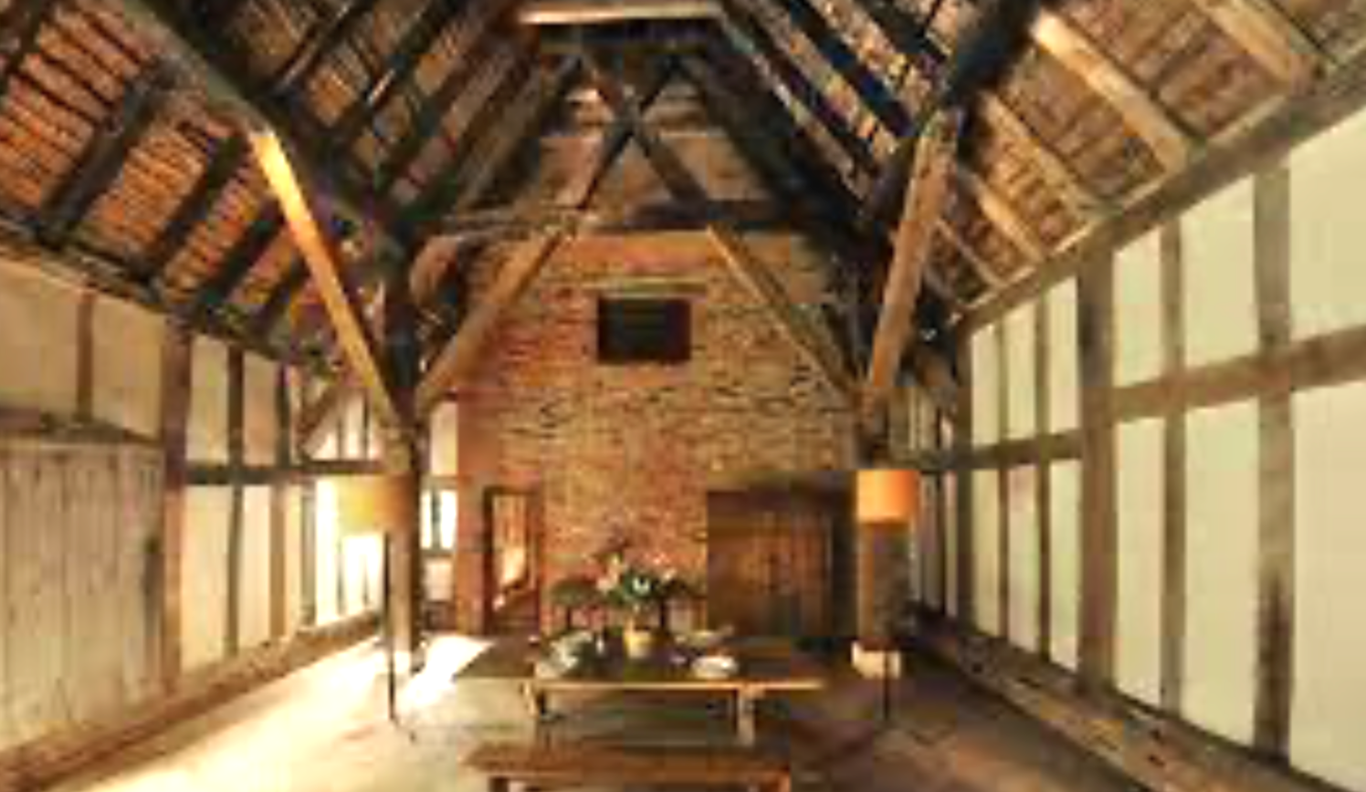

A talk by

JOHN WALKER

TUESDAY APRIL 15th, 7.30 pm

Haysel House – members free : non-members £5

