CODDENHAM VILLAGE HISTORY CLUB

DID THE SEWERS SAVE LIVES?
Public Health in Ipswich 1851 to 1911

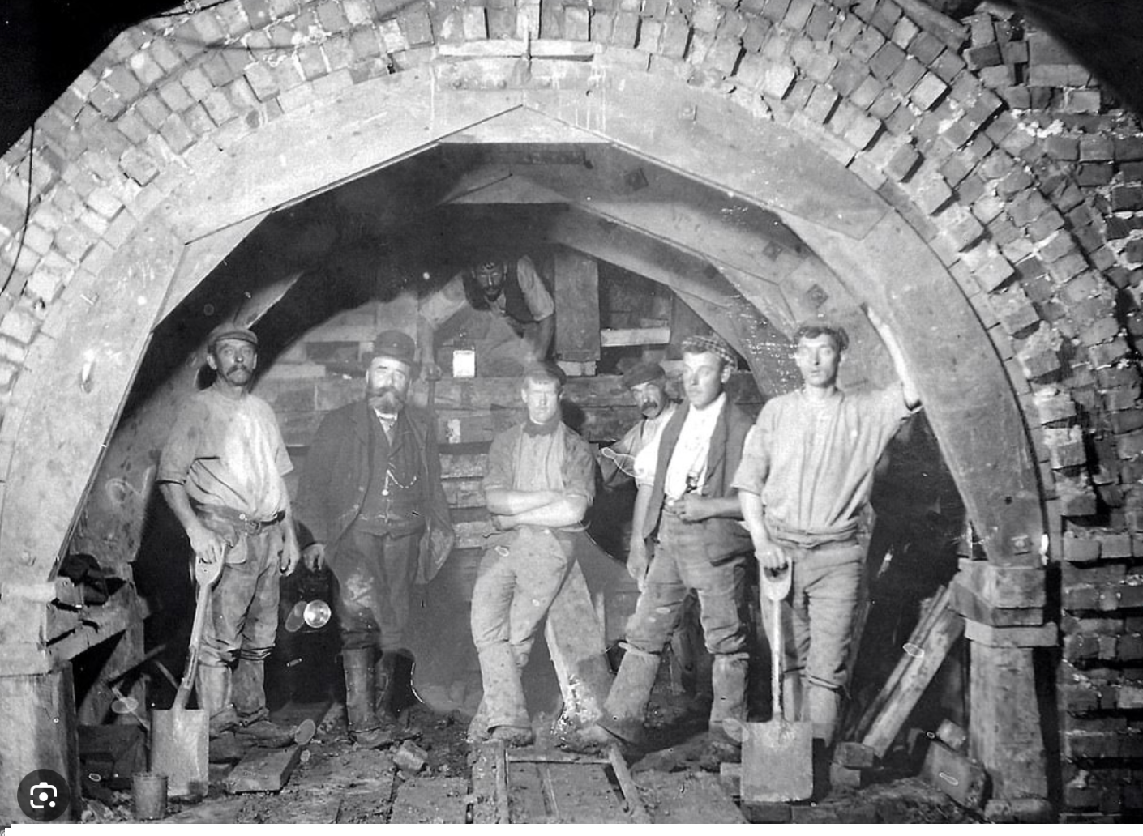

a talk by

DR ANNE FOLAN

TUESDAY 18th MARCH

7.30pm at Haysel House, Coddenham
Members free : Non-Members £5

