**PRESS RELEASE by the newly formed MID SUFFOLK INDEPENDENTS**

For immediate release:

**FOUR MID SUFFOLK COUNCILLORS FORM A NEW MID SUFFOLK INDEPENDENTS GROUP**

**Why we four district councillors are forming a new Mid Suffolk Independents group and are not jumping on the Labour devolution bandwagon.**

by James Caston, Lavinia Hadingham, Anders Linder and John Whitehead (Mid Suffolk district councillors)

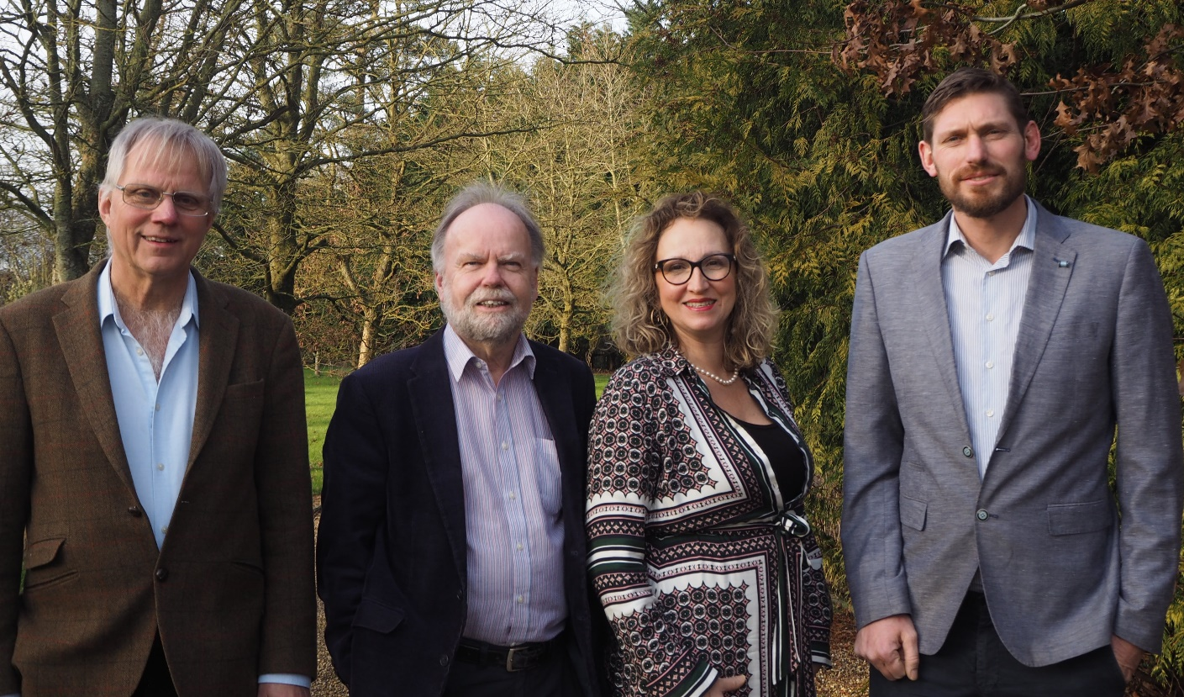

(from left to right – Anders Linder, John Whitehead, Lavinia Hadingham, James Caston)

Just prior to Christmas, the Labour government published a White Paper on devolution and local government reform. It set out a government plan for all rural shires to copy the mayoral structures currently established in many large urban conurbations whilst also abolishing the middle tier of local government – our present district and borough councils. A Mayoral Strategic Authority for East Anglia will almost certainly cover all of Norfolk and Suffolk creating an elected Mayor along with an extensive support function of public servants funded by a new council tax precept. This Mayor will most likely be based out of Norwich as the regional city of East Anglia. New large unitary councils will also need to be created. The government’s preferred size for these is at least half a million residents. That suggests one unitary, or possibly two, in each of Norfolk and Suffolk.

The White Paper gave a very tight deadline for response. County Councils had a deadline of 10th to request to be on the first wave of this initiative – the “Devolution Priority Programme”. At a hastily convened extraordinary meeting, Suffolk County Council met and agreed to jump onto this first wave. As a result, a lot of work will need to be undertaken in the coming months to create the Business Case; work by both councillors and officers at a time which would clash with the upcoming May 2025 county elections. The county councillors have therefore asked the government to cancel this May’s county election. The anticipated timetable would see a regional mayor elected in May 2026, and either one new unitary council, or possibly two, elected for Suffolk in May 2027. The new unitary council would run as a ‘shadow’ council for a year with a view to it taking on the county, borough and district service responsibilities from April 2028. From that date, the county, borough and district councils would cease to exist. Their names and legal structures consigned to history.

We four district councillors, with a combined experience of 35 years as district councillors at Mid Suffolk, are both appalled and dismayed that our Conservative county colleagues have so swiftly embraced this change imposed by the Labour government and agreed to extend their likely term in office from 4 years to possibly 7 years, serving unelected beyond their period of mandate and without any prior consultation with residents. They have also readily accepted the abolition of the borough and district councils which provide many valuable core universal services delivered locally to their residents. The Labour government say they want “fewer politicians” – fewer locally elected representatives and champions of their communities. We feel this shows a complete misunderstanding of why district councillors, like ourselves, stand for office and then put much time and effort into serving our local communities.

The county council administration believes these changes will bring more devolved finances to Suffolk whilst saving costs from the abolition of the borough and district councils. We believe the upheaval in the short to medium term will cause significant disruption to our council services, and will be costly in terms of the significant reorganisation required. It will remove an essential layer of local democracy whilst creating a significantly larger and more remote unitary body. We believe the actual cost savings it will achieve will be minimal and that the new regional mayor will create yet another remote and expensive layer of bureaucracy. To enable us to speak out against this top-down, Labour imposed change on our communities and the cancellations of the county elections, we four councillors have taken the drastic but necessary decision to step away from our Conservative group at Mid Suffolk. Instead, for the remainder of our time on the soon to be abolished Mid Suffolk District Council, we have come together to form a new group of Mid Suffolk Independents. It has been a far from easy decision to split from our Conservative colleagues in Suffolk but we feel those at county have come to a hasty and unwise decision in wholeheartedly embracing this top-down Labour devolution and reorganisation. With our move now, we are clearly and unequivocally disassociating ourselves from that decision and we will now speak with an independent voice for the remainder of our term in office, free to scrutinise and comment on this unnecessary and damaging reorganisation of local government in our area.

Contact : Cllr John Whitehead (Mid Suffolk Independents Group Leader) on 07889300898 or 01449 760521 Email : john.whitehead@midsuffolk.gov.uk